3.68: (a) When she catches the bagels, Henrietta has been jogging for 9.00 s plus the time for the bagels to fall 43.9 m from rest. Get the time to fall:
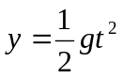
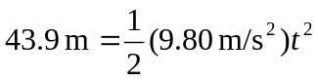
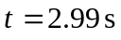

So she has been jogging for 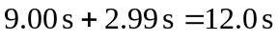. During this time she has gone . Bruce must throw the bagels so they travel 36.6 m horizontally in 2.99 s
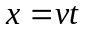
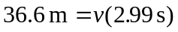
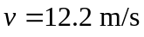

(b) 36.6 m from the building.

